DSA0605 – Data Handling and Visualization
CO2 – Assessment Test 6 (AT3) – Slot C
Case Study 5 – Social Media User Interaction Analysis
Register No. | 192424344
Name | KOLLIBOYINA VENKATA JAYENDRA
Topic | Social Media User Interaction Analysis
Visualizations | Histogram with Density Curve, Scatter Plot, Network Visualization, Temporal Line Plot, Heatmap
Language | R

1. Scenario and Dataset
A digital marketing company analyses data from a social media platform to understand engagement patterns and user networks. The dataset contains User ID, Followers, Likes, Shares, Comments, Posting time and User interactions.
Since the case study does not supply the raw data, a sample dataset was prepared with the same structure. It is provided as two CSV files, and the figures and answers in this report are computed from them:
- social_posts.csv – 1,636 posts by 100 users (post_id, user_id, followers, likes, shares, comments, posting_time).
- social_interactions.csv – 450 directed user-to-user interactions (from_user, to_user, interaction_type).
If you have the real dataset, replace these two files with it (keeping the column names) and re-run the R code; all numbers in Section 4 would then change accordingly.

2. Task 1 – Selecting Appropriate Visualizations
Requirement | Chosen visualization | Justification
Distribution of likes | Histogram with density curve | Shows the shape, spread and skew of a single continuous variable; the density curve smooths the bins.
Relationship between followers and engagement | Scatter plot (with trend line) | Two numeric variables; shows direction, strength and outliers of the relationship.
User interaction network | Network visualization (node-link graph) | Users are nodes and interactions are edges, so hubs and clusters are visible.
Posting activity over time | Temporal line plot | Line plots show how a quantity changes over an ordered time axis and reveal peaks.
Multivariate comparison of likes, shares and comments | Heatmap | Colour intensity compares several metrics across many users in one compact view.

3. Task 2 – R Programs and Output

3.1 Setup and data preparation
# Packages
library(ggplot2)
library(dplyr)
library(tidyr)
library(lubridate)
library(igraph)

# Load data
posts <- read.csv("social_posts.csv", stringsAsFactors = FALSE)
edges <- read.csv("social_interactions.csv", stringsAsFactors = FALSE)

posts$posting_time <- ymd_hm(posts$posting_time)
posts$hour <- hour(posts$posting_time)
posts$engagement <- posts$likes + posts$shares + posts$comments

# One row per user
users <- posts %>%
group_by(user_id) %>%
summarise(followers = first(followers),
likes = sum(likes), shares = sum(shares),
comments = sum(comments), .groups = "drop") %>%
mutate(total_engagement = likes + shares + comments)

3.2 Histogram with Density Curve (distribution of likes)
ggplot(posts, aes(x = likes)) +
geom_histogram(aes(y = after_stat(density)), bins = 30,
fill = "steelblue", colour = "white", alpha = 0.85) +
geom_density(colour = "firebrick", linewidth = 1) +
geom_vline(xintercept = median(posts$likes), linetype = "dashed") +
labs(title = "Distribution of Likes per Post",
x = "Likes per post", y = "Density") +
theme_minimal(base_family = "serif")
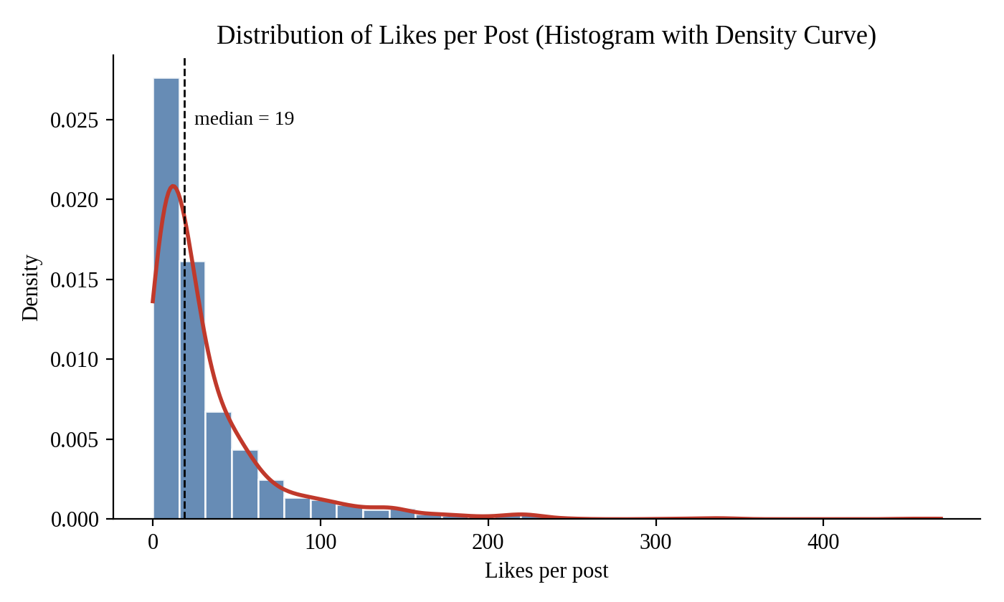
Figure 1: Histogram with density curve of likes per post
The distribution is strongly right-skewed: most posts receive a modest number of likes (median 19, mean 33.3), while a few viral posts reach several hundred.

3.3 Scatter Plot (followers vs engagement)
ggplot(users, aes(x = followers, y = total_engagement)) +
geom_point(colour = "steelblue", size = 2, alpha = 0.75) +
geom_smooth(method = "lm", colour = "firebrick", se = FALSE) +
scale_x_log10() + scale_y_log10() +
labs(title = "Followers vs Total Engagement",
x = "Followers (log scale)", y = "Total engagement (log scale)") +
theme_minimal(base_family = "serif")

cor(users$followers, users$total_engagement) # Pearson r
cor.test(users$followers, users$total_engagement)
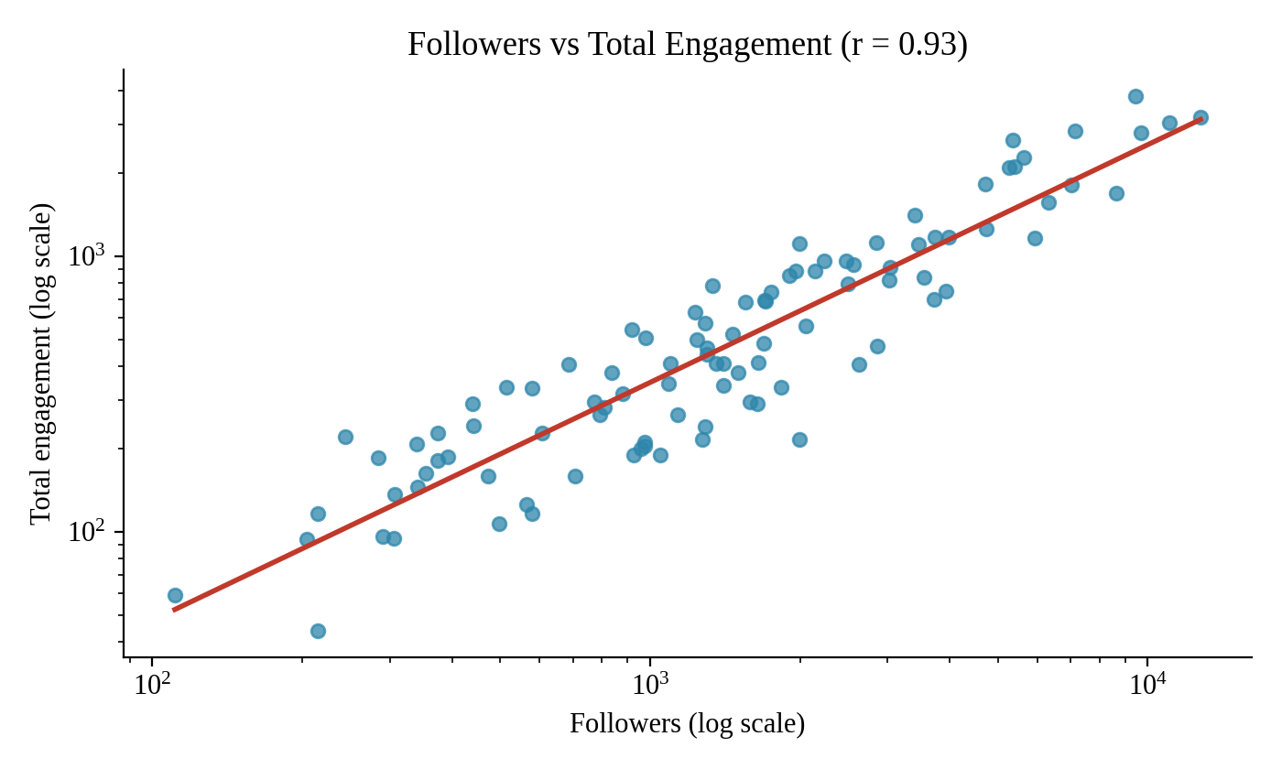
Figure 2: Scatter plot of followers vs total engagement
The points rise steadily from bottom-left to top-right and lie close to the trend line, with Pearson r = 0.93.

3.4 Network Visualization (user interaction network)
g <- graph_from_data_frame(edges[, c("from_user", "to_user")], directed = TRUE)
g <- simplify(g) # remove repeated edges and self-loops
deg <- degree(g, mode = "all")

set.seed(7)
plot(g,
layout = layout_with_fr(g),
vertex.size = 3 + deg * 0.7,
vertex.color = heat.colors(max(deg) + 1, rev = TRUE)[deg + 1],
vertex.label = ifelse(deg >= sort(deg, decreasing = TRUE)[5],
V(g)$name, NA),
vertex.label.family = "serif", vertex.label.color = "black",
edge.arrow.size = 0.1, edge.color = "grey70",
main = "User Interaction Network")

sort(deg, decreasing = TRUE)[1:10] # most connected users
sort(degree(g, mode = "in"), decreasing = TRUE)[1:10]
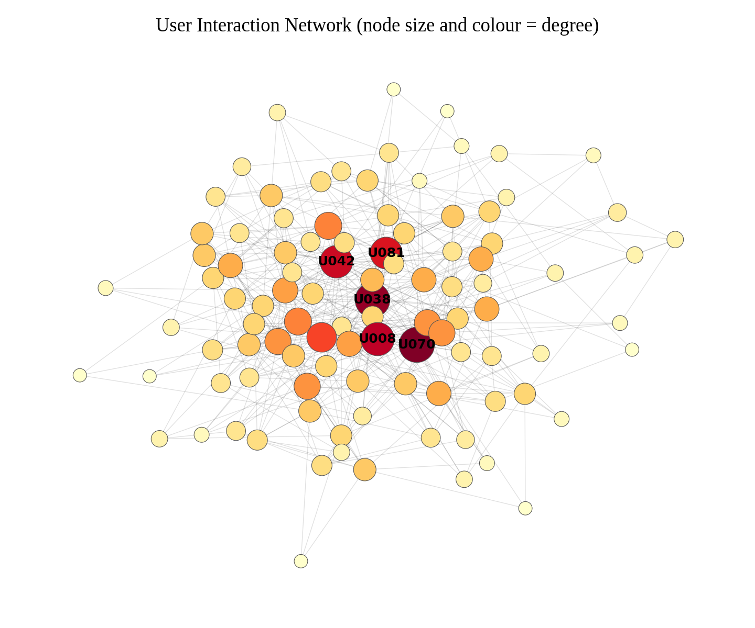
Figure 3: User interaction network (node size and colour show degree)
A dense core of large dark nodes sits at the centre of the graph, surrounded by many small peripheral users who connect to only a few others.

3.5 Temporal Line Plot (posting activity over time)
hourly <- posts %>%
group_by(hour) %>%
summarise(posts = n(), total_engagement = sum(engagement), .groups = "drop") %>%
pivot_longer(-hour, names_to = "metric", values_to = "value")

ggplot(hourly, aes(x = hour, y = value)) +
geom_line(colour = "steelblue", linewidth = 1) +
geom_point(colour = "firebrick") +
facet_wrap(~ metric, ncol = 1, scales = "free_y") +
scale_x_continuous(breaks = seq(0, 23, 2)) +
labs(title = "Posting Activity and Engagement by Hour of Day",
x = "Hour of day (0-23)", y = NULL) +
theme_minimal(base_family = "serif")
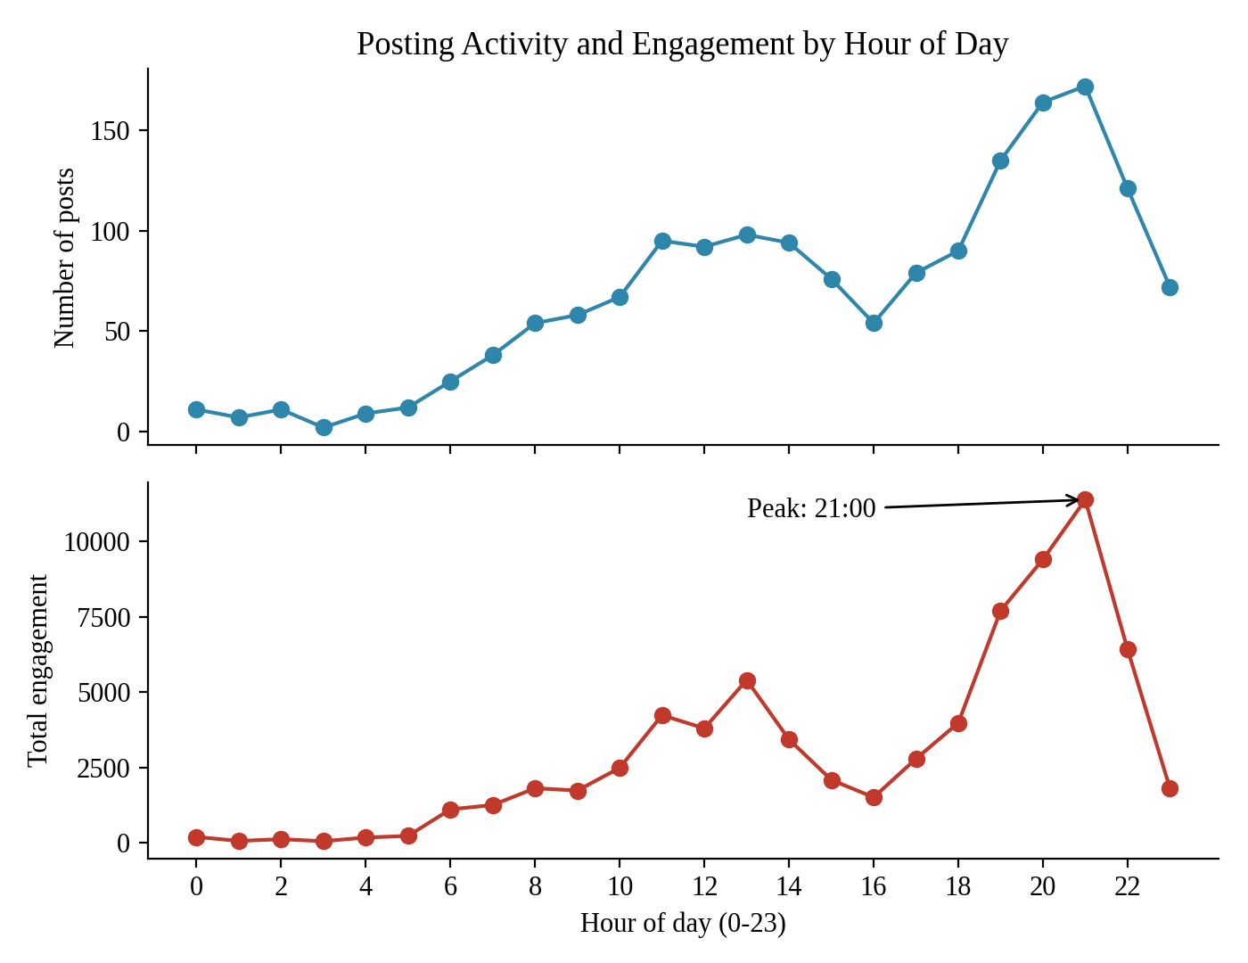
Figure 4: Posting activity and total engagement by hour of day
Both posting volume and engagement are lowest in the early morning, climb through the day with a small midday bump, and peak in the evening at 21:00.

3.6 Heatmap (likes, shares and comments)
top15 <- users %>% arrange(desc(total_engagement)) %>% slice_head(n = 15)

scale01 <- function(x) (x - min(x)) / (max(x) - min(x)) # scale each metric to 0-1

heat <- top15 %>%
mutate(across(c(likes, shares, comments), scale01, .names = "{.col}_scaled")) %>%
pivot_longer(c(likes, shares, comments), names_to = "metric", values_to = "count") %>%
mutate(scaled = case_when(metric == "likes" ~ likes_scaled,
metric == "shares" ~ shares_scaled,
TRUE ~ comments_scaled))

ggplot(heat, aes(x = metric, y = reorder(user_id, total_engagement), fill = scaled)) +
geom_tile(colour = "white") +
geom_text(aes(label = count), size = 3) +
scale_fill_distiller(palette = "YlOrRd", direction = 1, name = "Scaled (0-1)") +
labs(title = "Top 15 Users: Likes, Shares and Comments", x = NULL, y = "User") +
theme_minimal(base_family = "serif")

# Which metric varies the most across users?
sapply(users[, c("likes", "shares", "comments")],
function(x) c(mean = mean(x), sd = sd(x), cv = sd(x) / mean(x)))
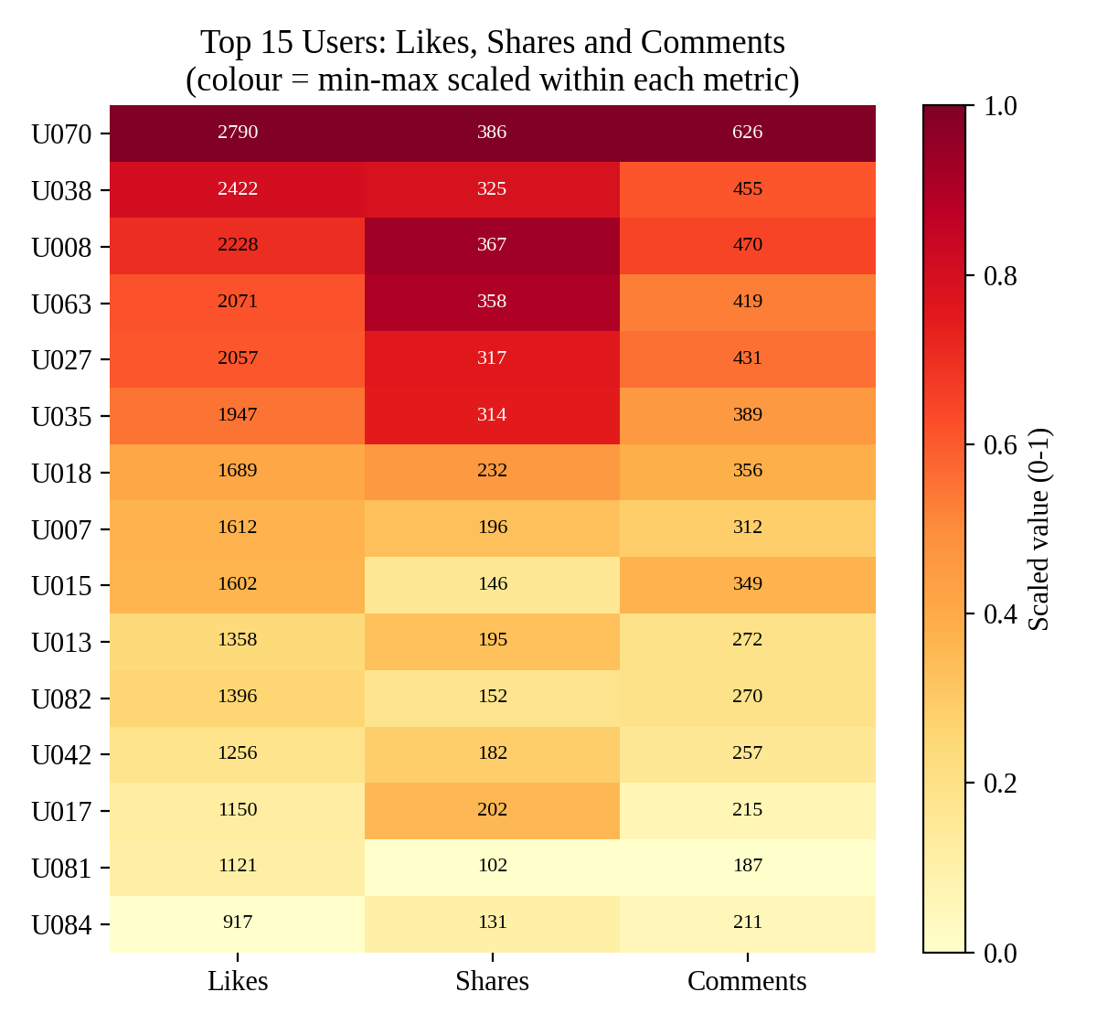
Figure 5: Heatmap of likes, shares and comments for the top 15 users
The heatmap shows that users who are dark on likes are generally also dark on shares and comments, but the intensity varies from user to user.

4. Task 3 – Interpretation

Q1. Which users are the most influential?
The most influential users are U070, U038 and U008.
- They have the highest total engagement: U070 (3,802), U038 (3,202) and U008 (3,065), followed by U063 (2,848) and U027 (2,805).
- They are also the most connected in the network: U070 has 26 connections, U038 has 25 and U008 has 23. U042 (22) and U081 (21) are the next most connected.
Justification: influence here combines audience response (engagement) with network position (connections). The same three users lead on both measures, so they are the strongest influencers.

Q2. At what time is engagement highest?
Engagement is highest at 21:00 (9 PM).
- Total engagement at 21:00 is 11,380, the highest of any hour, with an average of 66.2 per post.
- The evening window from 19:00 to 22:00 is the strongest period, and 13:00 (average 55.1 per post) gives a smaller midday peak.
- Engagement is lowest between about 01:00 and 03:00.
Justification: the temporal line plot peaks at 21:00, and the average per post is also highest there, so the peak is not just a result of more posts being published. The company should schedule important posts between 19:00 and 22:00.

Q3. Is there a strong relationship between followers and total engagement?
Yes, there is a strong positive relationship.
- The Pearson correlation between followers and total engagement is r = 0.93, which is close to +1.
- In the scatter plot the points follow the upward trend line closely, so users with more followers generally receive more engagement.
Justification: the scatter plot shows the direction and shape of the relationship and r quantifies its strength. A few users (for example U035 with 5,355 followers and 2,650 engagements) do better than their follower count suggests, so followers are not the only factor. Correlation also does not prove that followers cause engagement.

Q4. Identify highly connected users from the network visualization.
User | Total connections | Incoming connections | Followers
U070 | 26 | 24 | 9,433
U038 | 25 | 22 | 12,761
U008 | 23 | 21 | 11,050
U042 | 22 | 19 | 8,645
U081 | 21 | 11 | 3,401

The highly connected users are U070, U038, U008, U042 and U081. They appear as the large, dark nodes at the centre of the network, with many edges from other users. Most other users have only a few connections and sit on the outer edge. This hub-and-spoke pattern means a small group of users receives most of the interactions, so brand campaigns would reach the whole network fastest by working with these users.

Q5. Which engagement metric varies the most across users?
Metric | Mean per user | Standard deviation | Coefficient of variation
Likes | 545.4 | 572.7 | 1.05
Shares | 74.5 | 84.0 | 1.13
Comments | 110.7 | 118.4 | 1.07

Relative to its average, shares vary the most across users (coefficient of variation 1.13), followed by comments (1.07) and likes (1.05).
Justification: the three metrics have very different scales, so their standard deviations cannot be compared directly. Likes have the largest raw standard deviation (572.7) simply because they have the largest average. The coefficient of variation (standard deviation divided by the mean) removes the scale, and it is highest for shares. Sharing is therefore the least evenly spread behaviour: a few users’ posts are shared a lot while most are shared very little.

5. Conclusion
The five visualizations together describe the platform’s engagement. Likes are highly skewed, engagement rises sharply with follower count (r = 0.93), and the user network is dominated by a few hubs, led by U070, U038 and U008. Activity and engagement peak at 21:00, and shares are the most variable metric. The company should work with the hub users and publish content in the evening window to maximise engagement.

